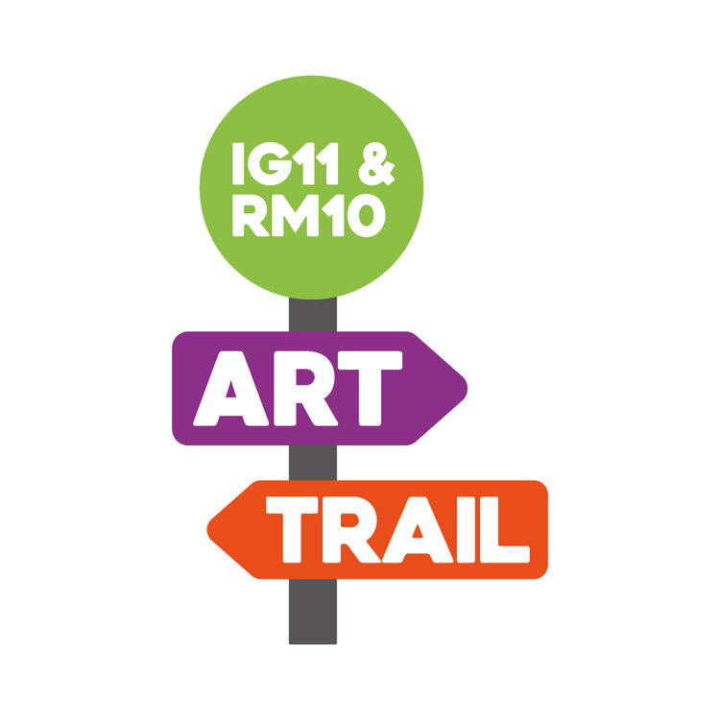
CALLING ALL ARTISTS IN BARKING & DAGENHAM.
STUDIO 3 ARTS’ IG11 AND RM10 ART TRAIL IS BACK AND OPEN TO ALL

The IG11 & RM10 Art Trail is back for a bumper fifth edition, celebrating culture and creativity in Barking & Dagenham through a trail of amazing outdoor public art that can be appreciated by and created by everyone in the borough.

Open to artists of all ages, all experience levels, and all backgrounds, Studio 3 Arts are inviting the whole borough to submit artworks for inclusion in this year’s trail, which will be on show between 18th October and 6th December on a walking route across Barking & Dagenham.

Artworks will be displayed outdoors in a public space this year, installed in parks, front gardens and balconies; outside schools, shops, and businesses; and on the streets on fences, walls, and railings. All art locations will be outlined on a special map and walking guide.

Artists should submit their artworks online to Studio 3 Arts by the submission deadline: 30th September. Anyone who has a suitable outdoor space where art can be exhibited should also get in touch by the same date, so that suitable spaces can be matched with brilliant artworks.

Artworks created in any format or medium are eligible, but they must be sent as a digital image as the works will be displayed on flat surfaces in outdoor locations. Any artwork (whether a drawing, painting, sculpture, or photograph) must be sent as a digital scan or photograph of the artwork.

It is free to submit and free to take part. Everyone is welcome and encouraged to submit their work for the project. Please send any questions to hello@studio3art.org.uk

More info about IG11 & RM10 Art Trail can be found here. Submit artworks and ideas for spaces in the form linked on the Art Trail page: https://www.studio3arts.org.uk/art-trail-2021

About Studio 3 Arts

Studio 3 Arts is a charity based in Barking & Dagenham at the forefront of socially-engaged, co-created arts. With local people at the heart of everything, the charity creates work in all art forms, in collaboration with communities, individuals and artists. Running a co-curated venue in the London Borough of Barking and Dagenham, Studio 3 Arts reaches across North East London and West Essex, to create real change in art and society. Central to Studio 3 Arts’ programme is the flagship youth project Big Deal. Using high-quality contemporary art forms to engage with young people aged 8 – 19, participants work with top industry professionals from a range of art forms including drama, street dance and music.

Studio 3 Arts’ physical home in Barking is currently undergoing a major £1.8m redevelopment and will reopen as a new world-class arts centre during winter 2021.

For further press information about the IG11 & RM10 Art Trail, please contact:

Chris O’ Kelly // chris@studio3arts.org.uk // 020 8594 7136
Matt Turner // matt@studio3arts.org.uk // 07932028337

